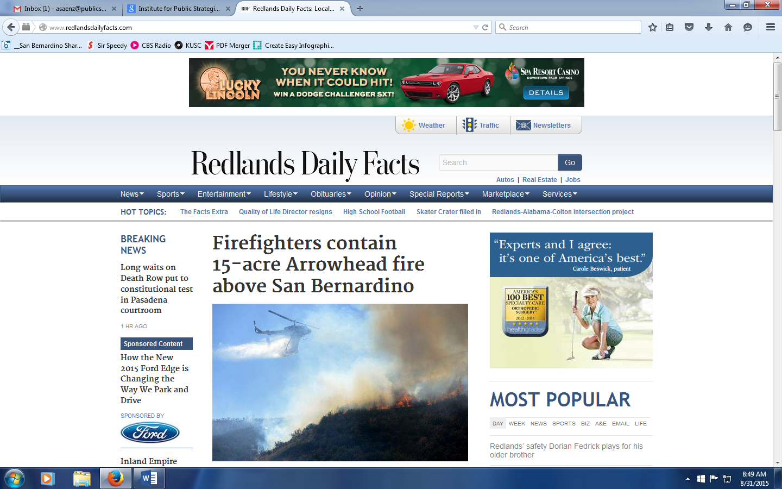

**Redlands businesses teaming up with police on alcohol problem**

By [Kristina Hernandez](http://www.redlandsdailyfacts.com/general-news/20150829/redlands-businesses-teaming-up-with-police-on-alcohol-problem#author1), Redlands Daily Facts

and [Sandra Emerson](http://www.redlandsdailyfacts.com/general-news/20150829/redlands-businesses-teaming-up-with-police-on-alcohol-problem#author2), Redlands Daily Facts

REDLANDS >> Redlands’ businesses are not only impacted by the Police Department’s Responsible Redlands initiative, they can participate.

The initiative, launched in August 2013, includes operations targeting businesses that overserve alcohol to patrons and to people under the legal drinking age.

“We always want to learn more (about programs in place), and we always want to support the Police Department,” Owen Williams, co-founder of Ritual Brewing Co., said. “So if they would like to do a program with our staff, we’d like to have that. And if they want to host a training downtown, we’d like to be part of that. We want to be that responsible party that everyone says, ‘Ritual does it right.’ And we want to always be actively involved.”

The department uses minor-decoy and shoulder-tap operations to ensure employees at businesses that sell alcohol follow the laws. The department also conducts DUI checkpoints and saturation patrols to target people driving under the influence of drugs or alcohol.

“I think the Police Department is doing an excellent job in creating a safe atmosphere for our customers and clients, which is what we are all about,” Kathie Thurston, executive director of the Redlands Chamber of Commerce, said. “So, in reading the initiative, it appeared to me that this (program) was just enforcing what is already on the books, and that they are really taking time, effort and energy with laser-like focus to keep our community safe, our business community safe and residents safe as well.”

Redlands police have been enforcing the city’s Deemed Approved Ordinance since it went into effect in March.

The [Deemed Approved Ordinance](http://www.redlandsdailyfacts.com/government-and-politics/20150204/redlands-gives-police-more-control-over-who-can-sell-alcohol) impacts businesses that sell alcohol, including liquor stores, grocery stores, convenience stores, bars, retail sales establishments, specialty food markets, beer and wine stores, bowling alleys and social halls.

Businesses that open after the ordinance was adopted must obtain a conditional use permit.

One of the conditions of the ordinance was employees at businesses that sell alcohol who were hired after Feb. 17 — the date of the passage of the ordinance — to complete Responsible Beverage Service training within 60 days. Existing staff had to complete the training six months after the passage.

Police and businesses teamed up on St. Patrick’s Day to catch minors using fake identification cards to purchase alcohol.

Employees who participated in trainings received ID scanners, ID books and magnifying glasses. These materials were funded by the State Incentive Grant program.

“A successful business community, particularly downtown, is an ‘after 5 (p.m.) lifestyle’ where there are restaurants and watering holes that stay open later,” Thurston said. “I know there have been issues (with alcohol related incidents) and the Police Department has addressed them well, most recently with the (Deemed Approved Ordinance).”

The fatal shooting outside of [Charlie Jewell’s](http://www.redlandsdailyfacts.com/general-news/20140801/randy-ortis-gets-99-years-to-life-for-shooting-outside-redlands-bar) in November 2011 is an example.

Police also get calls for other incidents related to drinking.

A California Department of Alcoholic Beverage Control grant provides funding for Informed Merchants Preventing Alcohol-Related Crime Tendencies, or IMPACT, inspections, Licensee Education on Alcohol and Drugs, or LEAD, classes for ABC-licensed businesses. Training is conducted by ABC’s Training/LEAD unit. The grant also covers officer overtime and equipment purchases.

Ritual has been part of ABC training hosted by the city.

Drugs are not allowed to be used on the premises and patrons cannot drink alcohol in the parking lot.

“We are constantly walking around and watching people ... to make sure they are not only safe but they are not consuming alcohol where they shouldn’t be,” he said. “We definitely will make sure they get a ride home one way or another whether it is through a designated driver or we’ll call them a taxi. We want our patrons to come back alive, and we want other people on the road to come back also.”

In December 2013, several bars and restaurants in town partnered with Redlands Cab Co. to offer patrons a free ride home. The program was named Responsible Redlands after the Police Department’s initiative.

Drink coasters reminding patrons to “drive sober or get pulled over” — a campaign through the National Highway Traffic Safety Administration — have also been made. The coasters include a Blood Alcohol Content chart so patrons can determine if they have imbibed too much to drive.

Ritual’s employees will also not serve patrons who are inebriated, even a group of people if one person is inebriated.

“It’s all about safety,” Williams said. “I have had friends that have been killed from drunk driving and that’s never fun. I never like seeing that, nor people picked up for drunk driving, but I would rather see that than hear that they killed somebody.”